**DSA Assignment - 18 June**

Name – Shwetank Tripathi

Roll.No - 22/11/EE/038

LeetCode Id – dumbledore_001

GeekforGeeks – dumbledore_001

Github Repo Link - /Shwetank-Tripathi/Practice

DSA- Section -

Question 1: Two Sum

Platform: LeetCode

Link: <https://leetcode.com/problems/two-sum/>

Submission Screenshot:

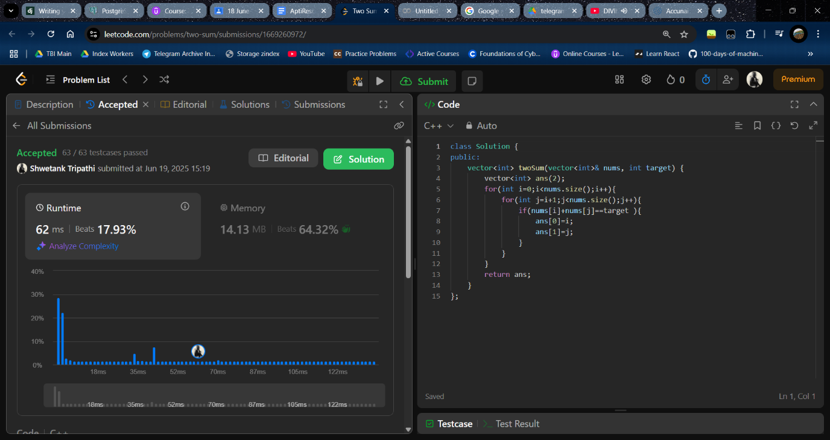

Question 2: Alone in Couple

○ Platform: GeeksforGeeks

○ Link: <https://www.geeksforgeeks.org/problems/alone-in-couple5507/0>

Submission Screenshot: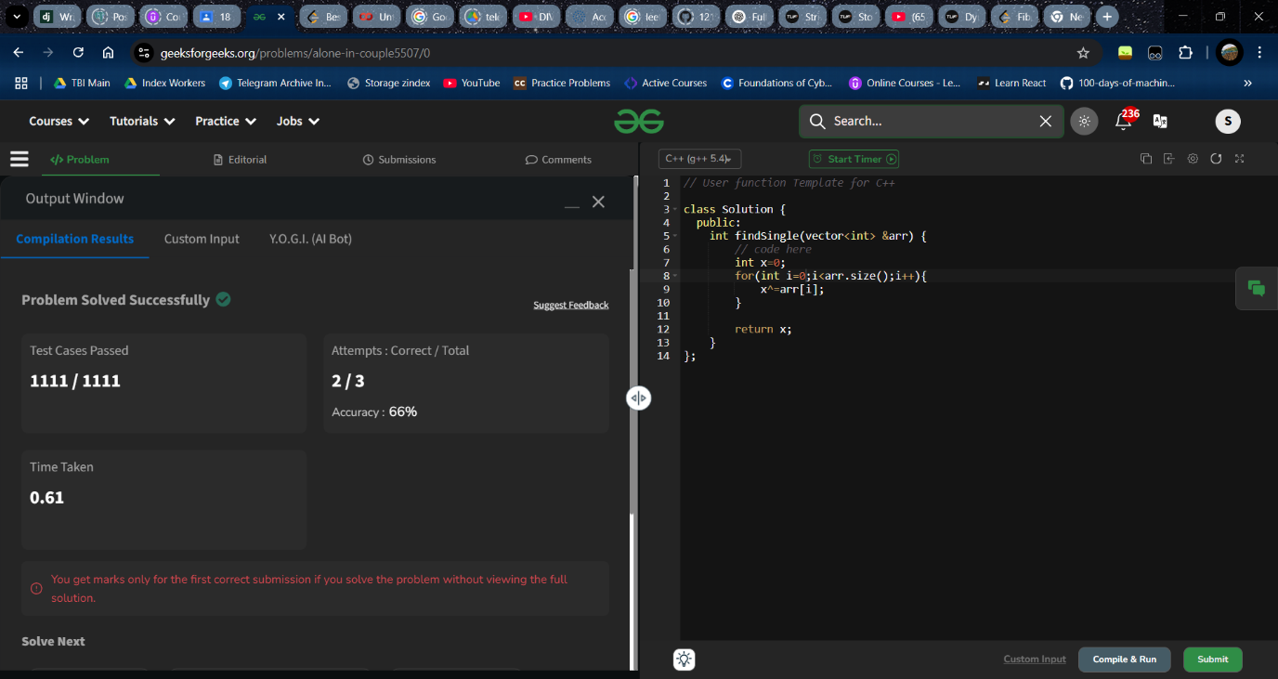

Question 3: Best Time to Buy and Sell Stock

○ Platform: LeetCode

○ Link: <https://leetcode.com/problems/best-time-to-buy-and-sell-stock/>

Submission Screenshot:

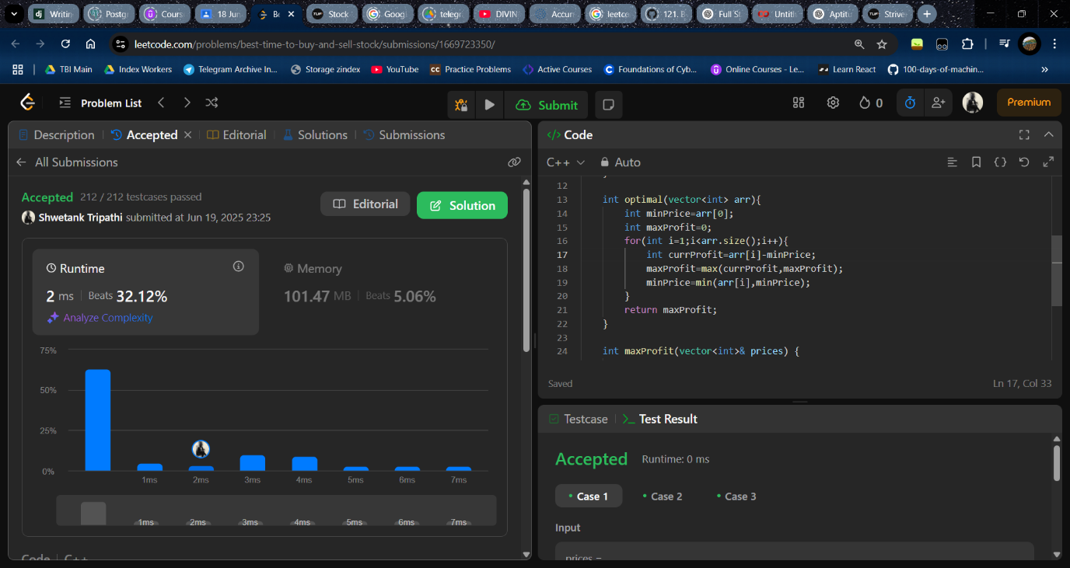

Question 4: Sort Colors

○ Platform: LeetCode

○ Link: <https://leetcode.com/problems/sort-colors/>

Submission Screenshot:

